Algebra 1: Unit 10, Lesson 2

- The graphs of the functions $y=|x+7|$ and $y=2$ are shown on the coordinate plane.
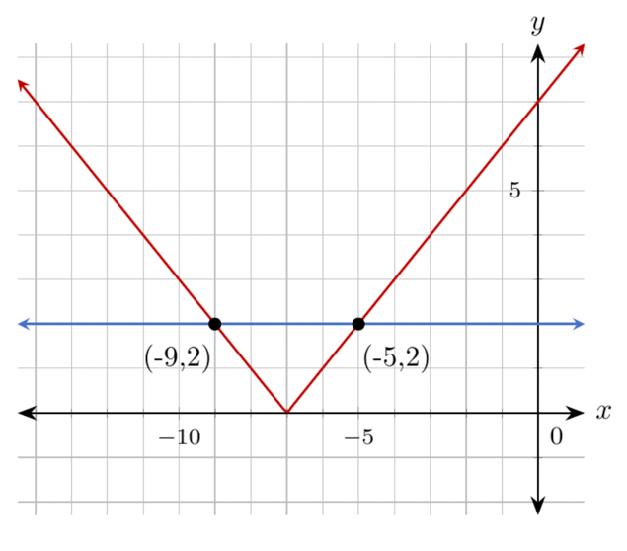
What are the minimum and maximum $x$-values for when the function $y=|x+7|$ is less than or equal to $2$?
Minimum is -9 and the maximum is -5

- A company develops computer chips that are $10$ nanometers $(nm)$ wide. Their acceptable variation is $0.0013 nm$.
What is the minimum acceptable size of a computer chip?
$$9.9987$$

- An absolute value function is shown.
$$f(x)=|x-25|$$What is the vertex of the function?
$(25,0)$

